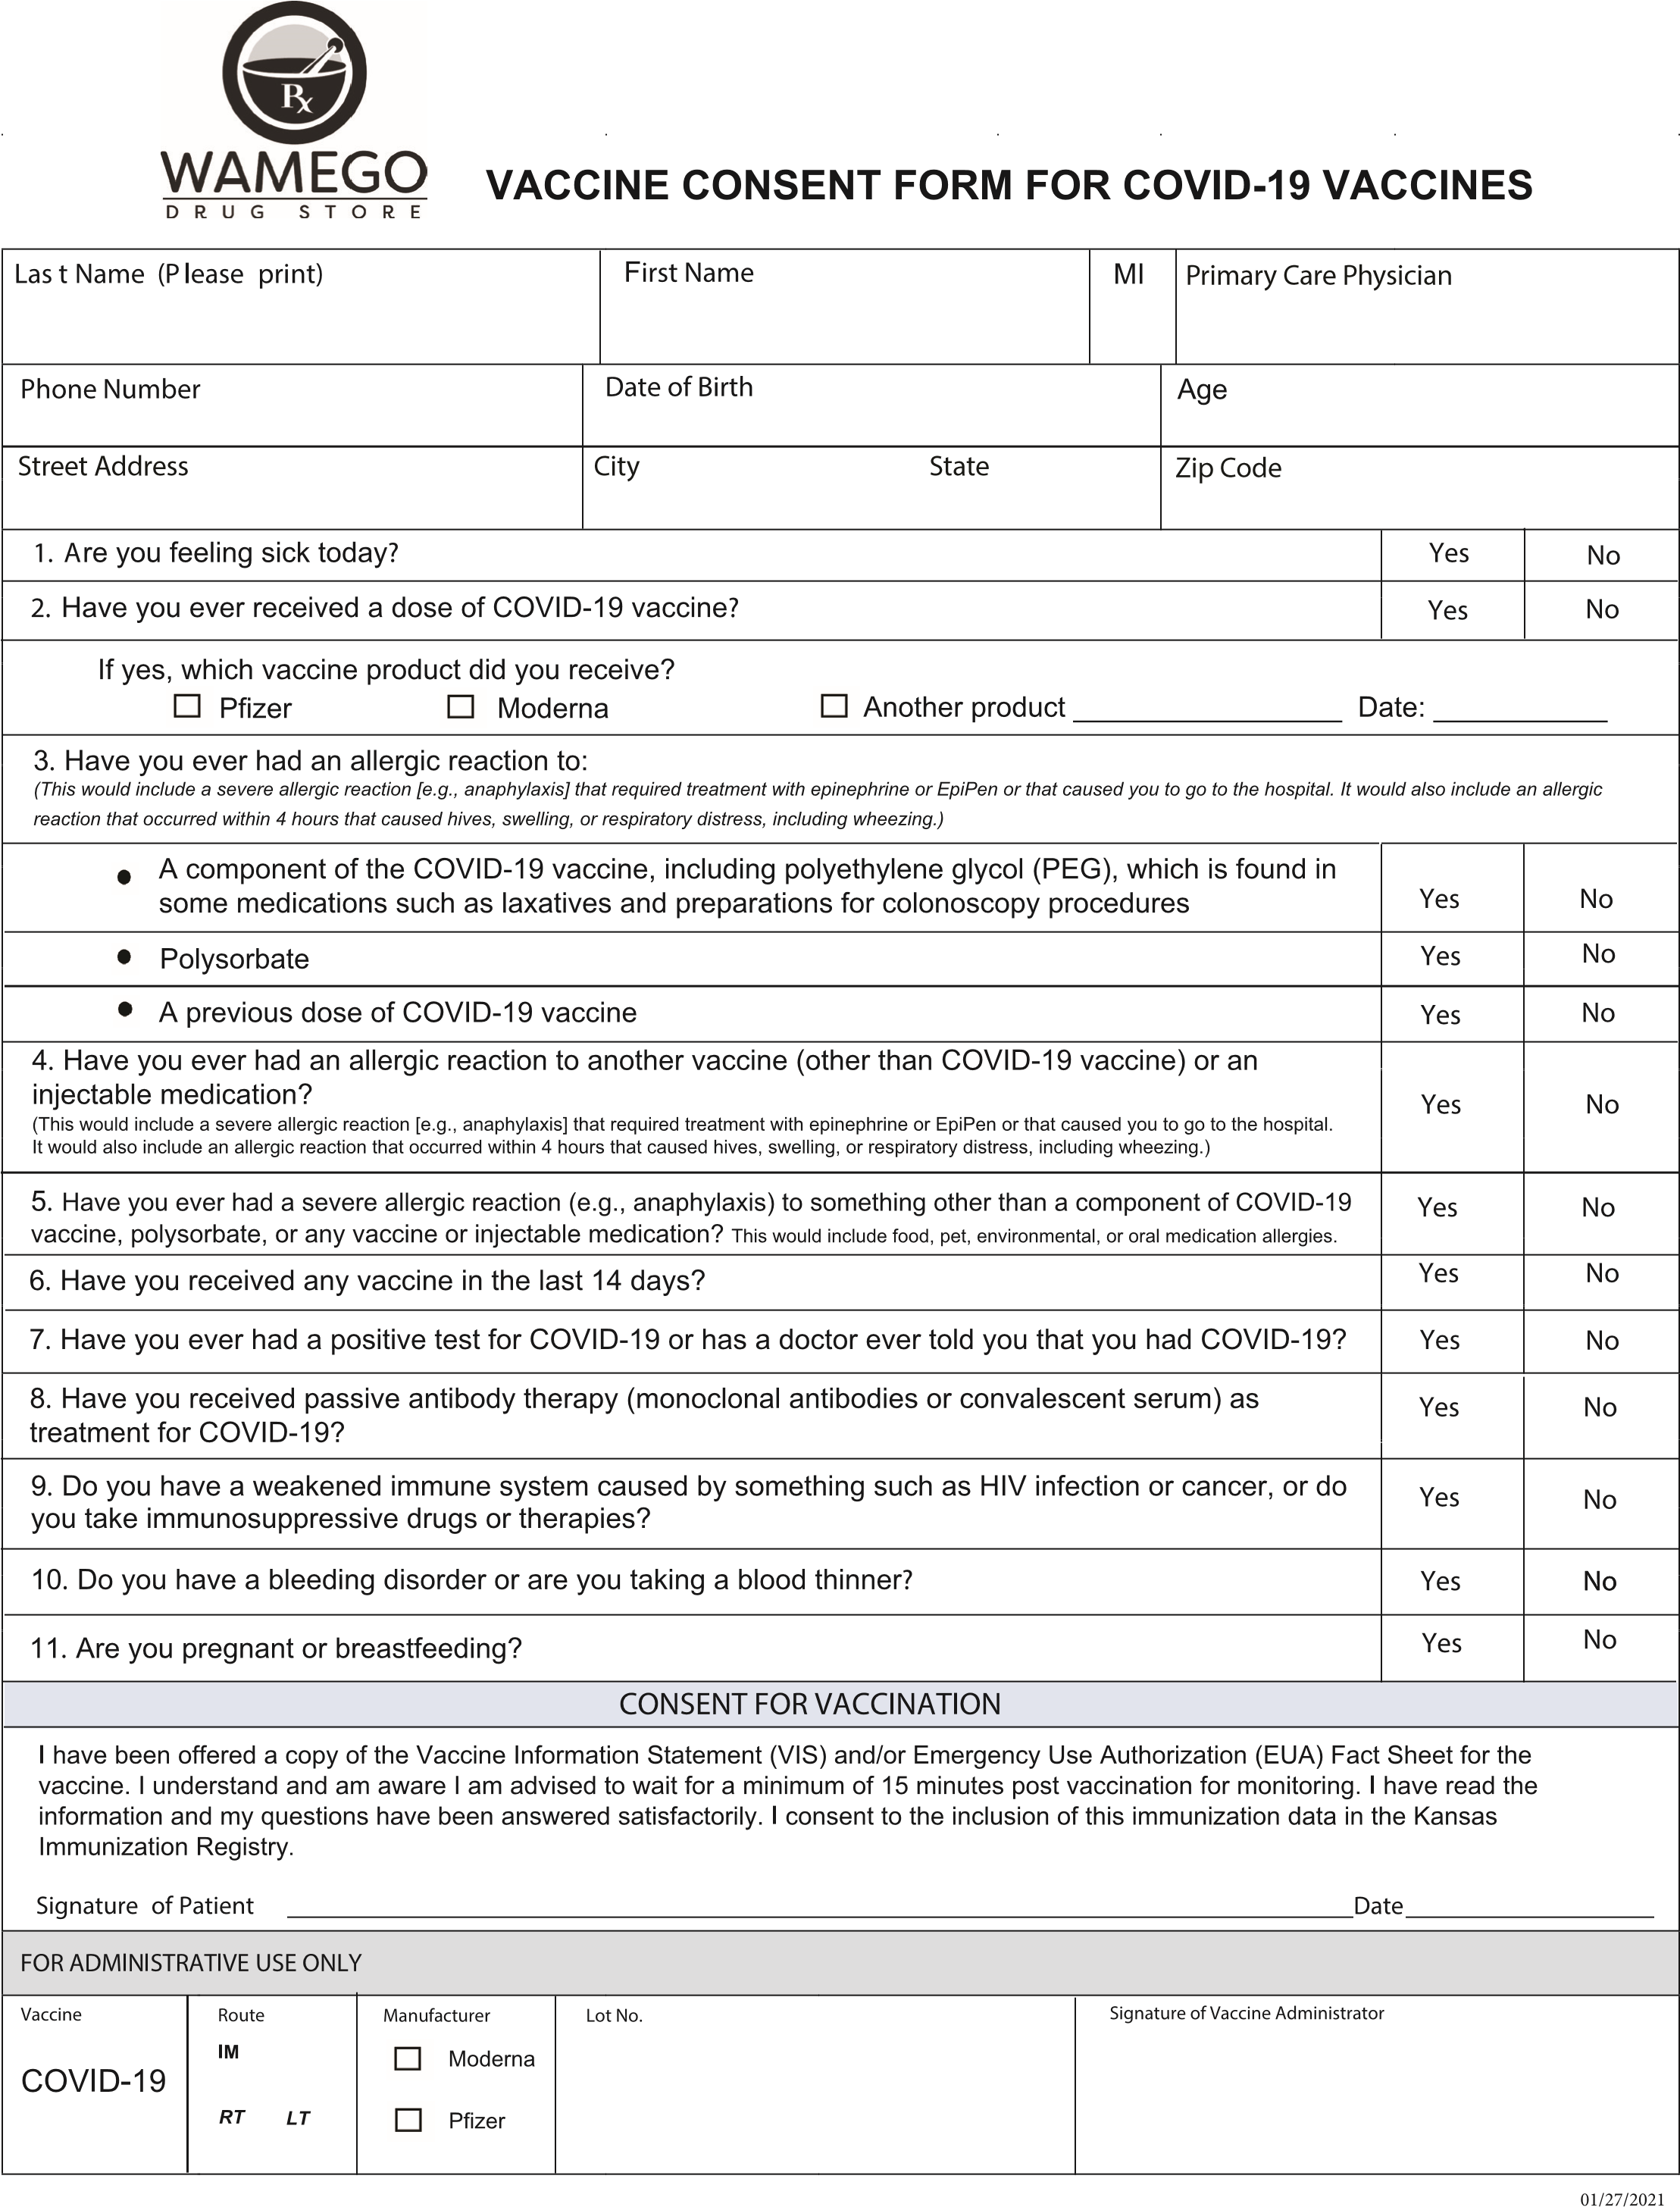
Ethnicity and Race
Prefer not to answer

Pfizer VIS date January 3, 2022 Moderna VIS date January 7, 2022 Pediatric VIS date January 3, 2022
No Insurance required, but if it is available please allow us to make a copy of your card for proper billing, thank you. Medicare Card (red, white and blue card) or Prescription Coverage Card.
Vaccination is free of cost to patient with or without insurance.

